**Exercise 1:**

**Exercise 2: The birthday paradox**

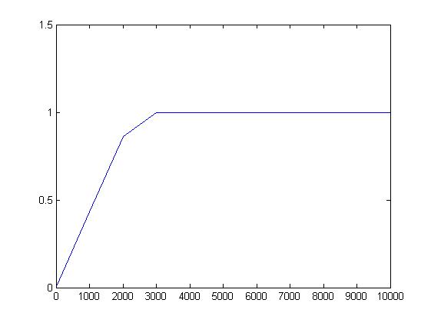

1. 0.95%
2. > 1200 elements
3. It is when something seems to be impossible but is in fact true.
4. The chance of collision in a hash table is way bigger than most probably think.